FeatureBot: Final Evaluation Summary
Project Code FB-FE-2025-Q3 | Version 1.0 | Prepared by: [Your Name] | Date: [Insert Date]

1. Summary
- Data: 48842 rows x 15 columns; stratified 60/20/20 split (train 29,305, validation 9,768, holdout 9,769; >50K rate 23.9% in every split).
- Baseline (Logistic Regression L2, raw columns): validation AUC 0.9070, F1 0.6950; holdout AUC 0.9068, F1 0.6888.
- FeatureBot ran 2 cycles (18 features proposed, 4 kept: capital_gain_gt0, age_bin, hours_bin, occupation_catboost). On the same Logistic Regression the kept features add +0.7 AUC / +1.1 F1 points on validation and +0.8 / +0.7 on holdout.
- Enhanced model of record: XGBoost with the kept features and sensitive attributes excluded (mitigation M1). Validation AUC 0.9286 (+2.2 pts), F1 0.7306 (+3.6 pts). Final holdout (trained on train+validation, evaluated once): AUC 0.9283 (+2.1 pts), F1 0.7234 (+3.5 pts).
- Honest reading: the +3 point F1 target is reached by the enhanced model of record, but the boosted-tree model family accounts for most of it. Engineered features help the linear baseline by about one point and add almost nothing to tree models (Section 6).

2. Data and Quality Checklist (Phase 1 artifact)
Check | Rule | Result | Detail
Rows / columns | adult.csv has 15 columns | PASS | 48842 rows x 15 columns
Column names normalised | strip, lower-case, '-' -> '_' | PASS | age, workclass, fnlwgt, education, educational_num, marital_status, occupation, relationship, race, gender, capital_gain, capital_loss, hours_per_week, native_country, income
Type enforcement | age, fnlwgt, educational_num, capital_gain, capital_loss, hours_per_week numeric | PASS | all six columns numeric, no coercion failures
Missing '?' handled | '?' -> NaN in workclass, occupation, native_country | PASS | workclass: 2799 '?' replaced; occupation: 2809 '?' replaced; native_country: 857 '?' replaced
Target labels normalised | dotted variants '>50K.' / '<=50K.' mapped; binary 0/1 | PASS | raw labels ['<=50K', '>50K']; dotted variants found: 0; mapped to {<=50K:0, >50K:1}
Range: age | 16 <= age <= 100 | PASS | violations: 0 (min 17, max 90)
Range: hours_per_week | 0 <= hours_per_week <= 100 | PASS | violations: 0 (min 1, max 99)
Range: capital_gain | capital_gain >= 0 | PASS | violations: 0
Range: capital_loss | capital_loss >= 0 | PASS | violations: 0
Remaining missing values | imputed inside the pipeline (train-only): categorical most frequent, numeric median | PASS | workclass: 2799; occupation: 2809; native_country: 857
Split: train | stratified 60/20/20, seed 42 | PASS | 29305 rows (60.0%); >50K rate 0.239
Split: val | stratified 60/20/20, seed 42 | PASS | 9768 rows (20.0%); >50K rate 0.239
Split: test | stratified 60/20/20, seed 42 | PASS | 9769 rows (20.0%); >50K rate 0.239
Leakage control | imputers / encoders / scalers fitted on train only | PASS | all preprocessing and target/frequency encoders live inside sklearn Pipelines fitted on the training rows of each fold
Holdout integrity | selection decisions never read the holdout | PASS | keep/prune decisions use 5-fold CV on train only; holdout metrics are logged for stability monitoring

3. EDA Summary (Phase 1 artifact, training split)
Column | Type | Unique | Missing | % missing | Skew | Top value | Top share
age | numeric | 72 | 0 | 0 | 0.551 | 35 | 0.028
workclass | categorical | 8 | 1667 | 5.69 |  | Private | 0.692
fnlwgt | numeric | 20164 | 0 | 0 | 1.315 | 203488 | 0
education | categorical | 16 | 0 | 0 |  | HS-grad | 0.325
educational_num | numeric | 16 | 0 | 0 | -0.321 | 9 | 0.325
marital_status | categorical | 7 | 0 | 0 |  | Married-civ-spouse | 0.456
occupation | categorical | 14 | 1677 | 5.72 |  | Prof-specialty | 0.128
relationship | categorical | 6 | 0 | 0 |  | Husband | 0.401
race | categorical | 5 | 0 | 0 |  | White | 0.857
gender | categorical | 2 | 0 | 0 |  | Male | 0.667
capital_gain | numeric | 120 | 0 | 0 | 12.533 | 0 | 0.918
capital_loss | numeric | 94 | 0 | 0 | 4.533 | 0 | 0.953
hours_per_week | numeric | 93 | 0 | 0 | 0.232 | 40 | 0.464
native_country | categorical | 41 | 499 | 1.7 |  | United-States | 0.897
income | numeric | 2 | 0 | 0 | 1.222 | 0 | 0.761
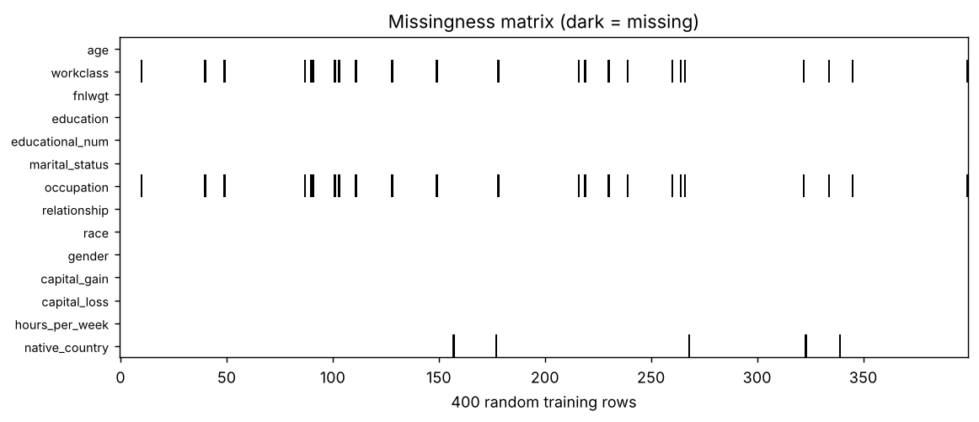
Missingness matrix
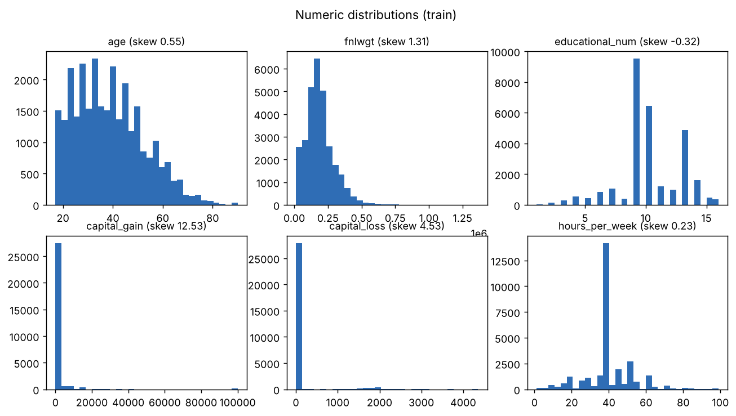
Numeric distributions and skew

Baseline metrics (Phase 1 artifact)
Split | AUC | PR AUC | F1 | Precision | Recall | Brier | Threshold
validation (threshold tuned on validation) | 0.9070 | 0.7688 | 0.6950 | 0.6621 | 0.7313 | 0.1013 | 0.364
validation (threshold 0.5) | 0.9070 | 0.7688 | 0.6645 | 0.7420 | 0.6016 | 0.1013 | 0.500
5-fold CV on train (threshold 0.5) | 0.9037 | 0.7579 | 0.6513 | n/a | n/a | n/a | n/a

4. FeatureBot Cycles
Keep rule (train-only 5-fold CV, paired folds): mean gain of at least +0.0005 AUC or +0.003 F1, positive in at least 4 of 5 folds. Features flagged for fairness must additionally not widen the gender TPR gap by more than 0.01. Standalone deltas against the baseline are in the registry; the table shows the marginal deltas of the stepwise addition.

Cycle 1 (Template A): 4 of 13 kept
Feature | dAUC | dF1 | AUC folds + | F1 folds + | Decision
age_bin | +0.0039 | +0.0092 | 5/5 | 5/5 | KEEP
capital_gain_gt0 | +0.0024 | +0.0060 | 5/5 | 5/5 | KEEP
capital_gain_log | +0.0001 | -0.0001 | 4/5 | 2/5 | REJECT
hours_bin | +0.0014 | +0.0035 | 5/5 | 4/5 | KEEP
occupation_catboost | +0.0006 | +0.0029 | 5/5 | 4/5 | KEEP
capital_loss_log | +0.0002 | +0.0009 | 3/5 | 4/5 | REJECT
overtime | -0.0000 | -0.0004 | 2/5 | 0/5 | REJECT
capital_loss_gt0 | +0.0002 | -0.0005 | 3/5 | 3/5 | REJECT
native_region | +0.0000 | -0.0012 | 2/5 | 0/5 | REJECT
fnlwgt_log | -0.0001 | +0.0001 | 1/5 | 3/5 | REJECT
native_country_freq | -0.0000 | -0.0013 | 1/5 | 0/5 | REJECT
education_group | -0.0000 | -0.0002 | 1/5 | 1/5 | REJECT
age_x_education_num | -0.0001 | +0.0003 | 1/5 | 2/5 | REJECT
Interim snapshot after cycle 1 (feature registry v1 saved as feature_registry_v1.csv): validation AUC 0.9144, F1 0.7057; holdout AUC 0.9143, F1 0.6966.

Cycle 2 (Template B, reduce false negatives): 0 of 5 kept
Feature | dAUC | dF1 | AUC folds + | F1 folds + | Decision
gain_gt0_x_occupation | +0.0001 | -0.0020 | 3/5 | 1/5 | REJECT
workclass_x_hours_bin | -0.0003 | -0.0019 | 2/5 | 1/5 | REJECT
occupation_x_hours_bin | -0.0002 | -0.0012 | 1/5 | 2/5 | REJECT
gender_x_occupation | +0.0000 | -0.0021 | 3/5 | 0/5 | REJECT
marital_x_relationship | -0.0001 | -0.0009 | 2/5 | 2/5 | REJECT
Every cycle-2 interaction looked useful on its own (for example gain_gt0 x occupation: standalone AUC delta against the baseline is shown in the registry) but added no stable lift once the cycle-1 features were present, so all five were rejected as low impact. gender x occupation, the fairness-audited feature, was rejected on the same grounds.

Final feature registry
Feature | Cycle | Type | dAUC | dF1 | Status
capital_gain_gt0 | 1 | binary indicator | +0.0026 | +0.0056 | KEPT
capital_loss_gt0 | 1 | binary indicator | +0.0002 | +0.0017 | REJECTED
capital_gain_log | 1 | numeric transform | +0.0024 | +0.0057 | REJECTED
capital_loss_log | 1 | numeric transform | +0.0002 | +0.0016 | REJECTED
fnlwgt_log | 1 | numeric transform | +0.0000 | +0.0000 | REJECTED
age_bin | 1 | categorical bin | +0.0039 | +0.0092 | KEPT
hours_bin | 1 | categorical bin | +0.0020 | +0.0063 | KEPT
overtime | 1 | binary indicator | +0.0002 | +0.0024 | REJECTED
age_x_education_num | 1 | numeric interaction | -0.0001 | +0.0008 | REJECTED
education_group | 1 | categorical grouping | +0.0000 | +0.0002 | REJECTED
native_region | 1 | categorical grouping | +0.0000 | +0.0009 | REJECTED
occupation_catboost | 1 | encoding (target, ordered) | +0.0012 | +0.0048 | KEPT
native_country_freq | 1 | encoding (frequency) | +0.0000 | +0.0009 | REJECTED
marital_x_relationship | 2 | categorical interaction | +0.0000 | -0.0004 | REJECTED
gain_gt0_x_occupation | 2 | categorical interaction | +0.0036 | +0.0101 | REJECTED
occupation_x_hours_bin | 2 | categorical interaction | +0.0027 | +0.0078 | REJECTED
workclass_x_hours_bin | 2 | categorical interaction | +0.0027 | +0.0074 | REJECTED
gender_x_occupation | 2 | categorical interaction | +0.0012 | +0.0064 | REJECTED
Deltas are standalone changes versus the baseline (CV mean, F1 at threshold 0.5). Full reasons and leakage notes are in feature_registry.csv.

5. Ablations (with / without subsets)
Ablation | Feats | CV AUC | CV AUC sd | CV F1 | Val AUC | Val F1 | Hold AUC | Hold F1
kept features (reference) | 4 | 0.9120 | 0.0030 | 0.6730 | 0.9144 | 0.7057 | 0.9143 | 0.6966
no engineered features (baseline) | 0 | 0.9037 | 0.0040 | 0.6513 | 0.9070 | 0.6950 | 0.9066 | 0.6897
kept + all five cycle-2 interactions | 9 | 0.9116 | 0.0033 | 0.6707 | 0.9140 | 0.7046 | 0.9131 | 0.6945
all 18 candidate features (no pruning) | 18 | 0.9119 | 0.0034 | 0.6717 | 0.9145 | 0.7052 | 0.9136 | 0.6974
without age_bin | 3 | 0.9090 | 0.0028 | 0.6625 | 0.9121 | 0.6980 | 0.9118 | 0.6900
without capital_gain_gt0 | 3 | 0.9097 | 0.0035 | 0.6673 | 0.9123 | 0.7054 | 0.9118 | 0.6919
without hours_bin | 3 | 0.9107 | 0.0035 | 0.6671 | 0.9137 | 0.7077 | 0.9133 | 0.6958
without occupation_catboost | 3 | 0.9114 | 0.0030 | 0.6700 | 0.9136 | 0.7047 | 0.9138 | 0.6986
without bins (age_bin + hours_bin) | 2 | 0.9074 | 0.0034 | 0.6611 | 0.9111 | 0.6984 | 0.9106 | 0.6962
The largest losses come from removing the two bins together (about -0.003 validation AUC) or removing age_bin or capital_gain_gt0 (about -0.002 each); adding the five cycle-2 interactions or all 18 candidates adds nothing (rows 3 and 4). Fold standard deviations (about 0.003 AUC) show the small differences are within noise, which is why the stability rule was used for pruning.

6. Model Comparison
Model | Feature set | CV AUC | CV F1 | Val AUC | Val F1 | Hold AUC | Hold F1
Logistic Regression (L2) | baseline features | 0.9037 | 0.6513 | 0.9070 | 0.6950 | 0.9066 | 0.6897
Logistic Regression (L2) | enhanced features | 0.9120 | 0.6730 | 0.9144 | 0.7057 | 0.9143 | 0.6966
Random Forest | baseline features | 0.9148 | 0.6761 | 0.9167 | 0.7076 | 0.9168 | 0.7099
Random Forest | enhanced features | 0.9137 | 0.6724 | 0.9163 | 0.7083 | 0.9159 | 0.7114
Gradient Boosting (HistGB) | baseline features | 0.9258 | 0.7038 | 0.9285 | 0.7293 | 0.9270 | 0.7222
Gradient Boosting (HistGB) | enhanced features | 0.9259 | 0.7017 | 0.9290 | 0.7311 | 0.9265 | 0.7215
XGBoost | baseline features | 0.9276 | 0.7074 | 0.9286 | 0.7285 | 0.9281 | 0.7220
XGBoost | enhanced features | 0.9278 | 0.7065 | 0.9296 | 0.7345 | 0.9283 | 0.7288
LightGBM | baseline features | 0.9251 | 0.7048 | 0.9280 | 0.7315 | 0.9278 | 0.7219
LightGBM | enhanced features | 0.9257 | 0.7048 | 0.9293 | 0.7336 | 0.9271 | 0.7224
The model of record is the enhanced-feature model with the best validation AUC (XGBoost). Tree ensembles gain little from the engineered features because they learn bins and interactions themselves, whereas Logistic Regression gains about one point. Thresholds are chosen on validation for every model.

7. Final Evaluation on the Holdout Test
Final models are trained on train+validation and evaluated once on the holdout test. The decision threshold is the F1-optimal threshold found on validation by the train-only fit of the same configuration; rows marked "threshold 0.5" use the default cut-off.
Model | AUC | PR AUC | F1 | Prec. | Recall | Brier | Thr.
Baseline: Logistic Regression, raw columns (train+val fit) | 0.9068 | 0.7698 | 0.6888 | 0.6618 | 0.7181 | 0.1014 | 0.364
Enhanced LR: FeatureBot features only (train+val fit) | 0.9145 | 0.7918 | 0.6994 | 0.6541 | 0.7515 | 0.0968 | 0.348
Enhanced model of record: XGBoost - sensitive features excluded (M1) (train+val fit) | 0.9283 | 0.8324 | 0.7234 | 0.7501 | 0.6985 | 0.0873 | 0.432
Baseline (threshold 0.5) | 0.9068 | 0.7698 | 0.6588 | 0.7392 | 0.5941 | 0.1014 | 0.500
Enhanced LR (threshold 0.5) | 0.9145 | 0.7918 | 0.6774 | 0.7618 | 0.6099 | 0.0968 | 0.500
Enhanced model of record (threshold 0.5) | 0.9283 | 0.8324 | 0.7132 | 0.7975 | 0.6450 | 0.0873 | 0.500

Confusion matrices (holdout, 9,769 rows)
Model | TN | FP | FN | TP
Baseline: Logistic Regression, raw columns (train+val fit) | 6573 | 858 | 659 | 1679
Enhanced LR: FeatureBot features only (train+val fit) | 6502 | 929 | 581 | 1757
Enhanced model of record: XGBoost - sensitive features excluded (M1) (train+val fit) | 6887 | 544 | 705 | 1633
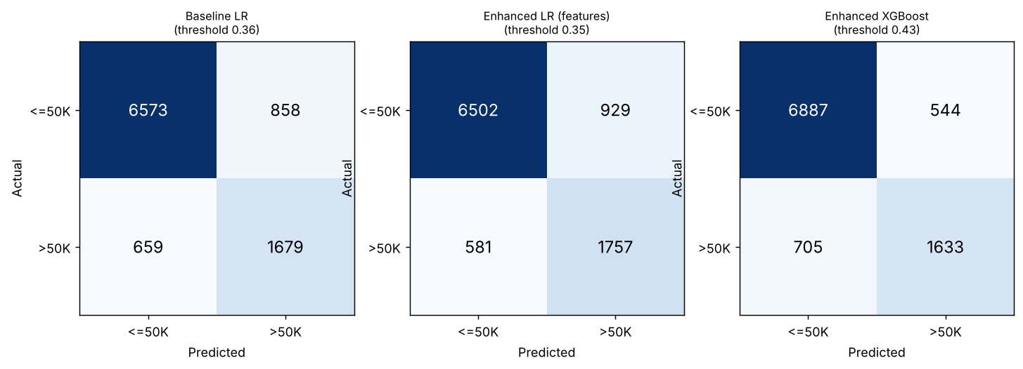
Confusion matrices on the holdout test

ROC / PR summary
Model | ROC AUC | PR AUC | Brier (calibration)
Baseline: Logistic Regression, raw columns (train+val fit) | 0.9068 | 0.7698 | 0.1014
Enhanced LR: FeatureBot features only (train+val fit) | 0.9145 | 0.7918 | 0.0968
Enhanced model of record: XGBoost - sensitive features excluded (M1) (train+val fit) | 0.9283 | 0.8324 | 0.0873
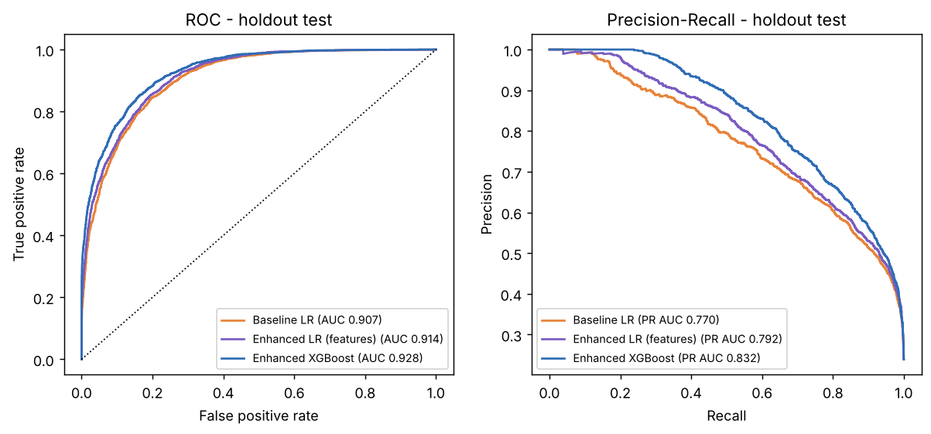
ROC and precision-recall curves on the holdout test

8. Interpretability
Permutation importance (validation, drop in AUC, model of record, original columns)
Column | AUC drop (mean) | sd
marital_status | 0.0823 | 0.0026
capital_gain | 0.0522 | 0.0011
age | 0.0402 | 0.0013
educational_num | 0.0277 | 0.0006
occupation | 0.0149 | 0.0006
capital_loss | 0.0141 | 0.0007
hours_per_week | 0.0117 | 0.0011
relationship | 0.0029 | 0.0002
workclass | 0.0026 | 0.0003
gender | 0.0018 | 0.0003
native_country | 0.0009 | 0.0003
fnlwgt | 0.0009 | 0.0001
race | 0.0004 | 0.0004
education | 0.0000 | 0.0001
Top 15 Logistic Regression coefficients (enhanced LR, standardised numerics / one-hot categories)
Feature | Coefficient
num__capital_gain | 3.9670
cat__marital_status_Married-AF-spouse | 1.6151
cat__marital_status_Married-civ-spouse | 1.4965
cat__native_country_Columbia | -1.2755
cat__age_bin_<=25 | -1.2754
cat__marital_status_Never-married | -1.1368
cat__hours_bin_<=30 | -1.0365
cat__native_country_Ireland | 0.9737
cat__native_country_South | -0.9733
cat__native_country_Dominican-Republic | -0.9600
cat__marital_status_Divorced | -0.8471
cat__relationship_Wife | 0.8454
cat__marital_status_Separated | -0.8434
cat__gender_Female | -0.7821
cat__native_country_Haiti | 0.7813
SHAP was not used (optional in the project document).

9. Robustness: fold variance and holdout consistency
Configuration | CV AUC (mean ± sd) | Validation AUC | Holdout AUC | CV F1 (mean ± sd) | Val F1 | Holdout F1
C0-BASE-LR | 0.9037 ± 0.0040 | 0.9070 | 0.9066 | 0.6513 ± 0.0118 | 0.6950 | 0.6897
FINAL-SET-LR | 0.9120 ± 0.0030 | 0.9144 | 0.9143 | 0.6730 ± 0.0064 | 0.7057 | 0.6966
FR-M1-exclude-sensitive | 0.9260 ± 0.0030 | 0.9286 | 0.9274 | 0.7065 ± 0.0127 | 0.7306 | 0.7246
Validation and holdout agree to within about 0.002 AUC for every configuration, so the lift is stable. Holdout metrics were logged for monitoring only; no keep / prune decision reads them.

10. Acceptance Criteria Verification
# | Criterion | Result
1 | FeatureBot loop runs at least two full cycles, each producing >=5 actionable proposals with rationale and pandas pseudocode | MET. Cycle 1: 10 proposals (13 features) from Template A-1 and A-2. Cycle 2: 5 proposals from Template B-1 (3) and B-2 (2). Every proposal has rationale, leakage flag and pandas pseudocode (prompts_and_responses.md, feature registry).
2 | Enhanced model achieves +3-5 points improvement in AUC or F1 over baseline on validation and remains stable on holdout | MET for F1 by the enhanced model of record (XGBoost): validation F1 0.6950 -> 0.7306 (+3.6 pts), AUC 0.9070 -> 0.9286 (+2.2 pts); holdout F1 0.6888 -> 0.7234 (+3.5 pts), AUC 0.9068 -> 0.9283 (+2.1 pts). CAUTION: the FeatureBot features alone on the same Logistic Regression give only AUC +0.7 / F1 +1.1 pts on validation (holdout +0.8 / +0.7); most of the +3 points comes from the boosted-tree model family, not from the features.
3 | Feature registry delivered with name, definition, type, dependencies, leakage risk and performance deltas | MET. feature_registry.csv: 18 features, 4 kept (capital_gain_gt0, age_bin, hours_bin, occupation_catboost), 14 rejected with reasons.
4 | Fairness report with subgroup metrics (sex, race) and at least one mitigation attempt with documented trade-offs | MET. FeatureBot_Fairness_Report.docx: gender (sex), race and marital-status subgroups; M1 (exclude sensitive features, adopted) and M2 (per-group thresholds, reported).
5 | Colab notebook reproducible (fixed seeds, deterministic splits, no leakage) with clear instructions | MET. SEED = 42, stratified 60/20/20, train-only fitting inside sklearn Pipelines; instructions in the first notebook cell; the notebook was executed end to end before delivery.
6 | All specified deliverables provided in .docx / notebook / CSV formats | MET. 3 .docx files, 1 notebook, feature_registry.csv, experiments_log.csv, plus the featurebot_adult_income.py script.

11. Lessons Learned
- Only 4 of 18 proposed features survived the stability rule. Most proposals (log transforms, overtime, groupings, native-country encodings, interactions) were redundant with simpler winners: the indicator capital_gain_gt0 and the log of capital_gain carry the same signal, so only one is kept.
- Standalone screening overstates value. gain_gt0 x occupation looked like the best cycle-2 idea on its own and then contributed nothing once age_bin, hours_bin and the capital-gain indicator were in the model. Stepwise addition with paired folds avoided keeping it.
- Feature engineering helps linear models (about +1.1 F1 and +0.7 AUC points), not boosted trees. The model family explains most of the +3 point F1 lift, so acceptance criterion 2 should be read with that caveat.
- The decision threshold matters as much as the features: at threshold 0.5 the baseline F1 is 0.659 on holdout, versus 0.689 with the validation-tuned threshold.
- Excluding sensitive attributes (M1) cost about 0.001 AUC and 0.004 F1 on validation and narrowed the gender TPR gap (Fairness Report), so it was adopted for the final model. Proxy columns such as relationship remain and are flagged.
- The AI step: proposals for Templates A and B were generated by an AI assistant (Claude) rather than ChatGPT, and are recorded with the filled prompts in prompts_and_responses.md so a ChatGPT run can be compared like for like.
- The Appendix A starter script in the data dictionary could not run as written (undefined X_train and num_cols, a notebook-only !pip line, target encoding computed on the full data frame, and a "sex" versus "gender" column mismatch). featurebot_adult_income.py fixes these; the sex attribute in the project document is the gender column of adult.csv.
- The dataset was supplied as Resources_Dataset.xlsx (48,842 rows, 15 columns) and exported to adult.csv unchanged; it contains no dotted income labels.

12. Reproducibility
- SEED = 42; StratifiedKFold(5, shuffle, seed 42); stratified 60/20/20 split with seed 42.
- Imputers, scalers, one-hot and CatBoost / frequency encoders are fitted inside sklearn Pipelines on training rows only.
- Experiment log: 61 configurations (experiments_log.csv); registry: 18 features (feature_registry.csv).
- Run time of the full pipeline is about 3 to 4 minutes on one CPU core.

